# TECHNICAL DATASHEET

**5W Compact Fixed Blade USB Charger – UK**

**Applications**

• Smart Phones

• PDAs

• Personal Electronics

• Digital Cameras

**Features**

• Fixed Blade

• Low Profile

• Low Cost

• Ecodesign/ErP Lot 7 (EU) 2019/1782 Compliance

• The charging scheme: Data Lines (Pins 2

and 3) Shorted**Safety Standards**

**Dimensions**

49.5 x 48.3 x 20.8 mm

(1.95 x 1.90 x 0.82 inch)

**Specification1**

|  |  |  |  |  |
| --- | --- | --- | --- | --- |
| Model | | PSAA05K-050QL6-R2 | PSAA05K-050QL6W-R2 | |
| Output | DC Output Voltage | 5.0V | | |
| Max Current | 1.0A | | |
| Output Power | 5.0W | | |
| Regulation | ± 5% | | |
| Ripple & Noise P-P(max)3 | 200mV | | |
| Input | AC Input Voltage Range | 90 to 264VAC | | |
| AC Input Frequency | 47 to 63Hz | | |
| Input Current | 0.2A(RMS) max at 115VAC; 0.15A(RMS) max at 230VAC | | |
| Inrush Current | 30A max @264VAC (cold start @ambient 25°C) | | |
| No Load Power Consumption at 230VAC Input | 0.0365W | | |
| 230VAC Average Efficiency4 | 74.65% | | |
| 230VAC 10% Load Efficiency | 70.65% | | |
| Leakage Current | 0.025mA max | | |
| Protection | Over-Voltage | <7.5V | | |
| Over-Current | 1.5A max | | |
| Short Circuit | The output can be shorted without damage. Auto restart. | | |
| Environmental | Operating Temperature | -10⁰C to +45⁰C | | |
| Non-Operating Temperature | -40⁰ to +70⁰C | | |
| Operating Humidity | 5 to 95% | | |
| Safety Approvals and EMC | Dielectric Withstand (HI-POT) | Primary to Secondary: 3000VAC for 1min, 10mA | | |
| Insulation Resistance | Primary to Secondary: 10M ohm for 500VDC | | |
| Standards | IEC 62368-1 | | |
| EMI Emissions | EN 55032/CISPR 32 Class B Conducted and Radiated | | |
|  | Harmonic Current Emissions | IEC 61000-3-2 | | |
|  | Voltage Fluctuations & Flicker | IEC 61000-3-3 | | |
|  | Immunity | EN 55035/CISPR 35; IEC 61000-4-2 (+/-4kV contact, +/-8kV air), IEC 61000-4-3, IEC 61000-4-4, IEC 61000-4-5 (+/-1kV), IEC 61000-4-6, IEC61000-4-8, IEC 61000-4-11 | | |
| Mechanical | Dimensions (L x W x H) | 49.5mm (1.95in) x 48.3mm (1.90in) x 20.8mm (0.82in) | | |
| Weight | 25g | | |
| DC Output Connector | USB CONN, 4PIN. D+ D- shorted, compliant to USB BC1.2 | | |
| Case Color | Black | | White |
| Notes | 1. The specifications defined are at ambient temperature of 25C, unless otherwise specified.  2. Special order item. Minimum order quantity applies.  3. 20MHz bandwidth frequency oscilloscope, add a 0.1μF multilayer Cap. and Low ESR Electrolytic Cap. (10μF) at output connector terminals (nominal line voltage, full load).  4. Efficiency is measured after 30 minutes burn-in. | | | | |

Phihong is not responsible for any error and reserves the right to make changes without notice. Please visit our website

at www.phihong.com for the most up-to-date specifications and contact information.

**Dimensional Diagram Unit: mm**

**\**

**USB Cables – Sold Separately Unit: mm**

|  |  |
| --- | --- |
| Part no: IP-USB1(C10)S | Desc: USB-A to Micro-B – 1 Meter – Black |
|  | |
| Part no: IPUSB1CS | Desc: USB to Mini-B – 1.5 Meter – Black |
|  | |
| Part no: IPUSB1MS | Desc: USB-A to Micro-B – 1.5 Meter – Black |
|  | |
| Part no: IPUSB1M5LD | Desc: USB-A to Micro-B – 24AWG – Low Drop – 1.5 Meter – Black |
|  | |
| Part no: IPUSB1P5 | Desc: USB-A to Micro-B – 1 Meter – 24AWG – Black |
|  | |
| Part no: IPUSB1P5W | Desc: USB-A to Micro-B – 1 Meter – 24AWG – White |
|  | |
| Part no: IPUSB1MSW | Desc: USB-A to Micro-B – 1.5 Meter – White |
|  | |

|  |  |
| --- | --- |
| Part no: UES-1001A160 | Desc: Low Drop Type-C USB Cable – 1 Meter – 23AWG on  Power – 30AWG on Data - Black |
|  | |
| Part no: UES-1003A160 | Desc: Low Drop Type-C USB Cable - ! Meter – 23AWG on  Power – 30AWG on Data - White |
|  | |

**Phihong Locations**

## 一張含有 戶外, 建築, 樹狀, 公寓 的圖片 自動產生的描述Headquarters Phihong Technology Co., Ltd

No.568, Fuxing 3rd Rd., Gueishan Dist., Taoyuan City (33383), Taiwan Tel : +886-3-3277288

Fax : +886-3-3277622

[phsales@phihong.com.tw](mailto:phsales@phihong.com.tw) [www.phihong.com.tw](http://www.phihong.com.tw/)

## 一張含有 戶外, 天空, 樹狀, 房地產 的圖片 自動產生的描述Phihong Technology Co. Ltd. (Tainan R&D Center)

No. 99, Zhengnan 1st. Street, Yongkang Dist., Tainan City 71046, Taiwan

Tel : +886-6-254-7588

Fax : +886-6-254-7288

[phsales@phihong.com.tw](mailto:phsales@phihong.com.tw) [www.phihong.com.tw](http://www.phihong.com.tw/)

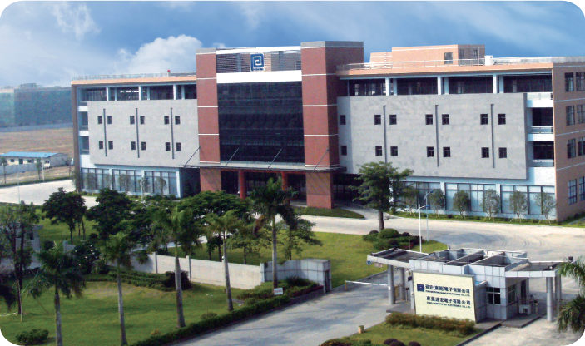

## Phihong China

Room 101, Building 5,133-1 TiesongRoad, QingxiTown, Dong Guan City, GuangDong(523642), China

Tel : +86-769-87736405

[phsales@phihong.com.tw](mailto:phsales@phihong.com.tw)

## Phihong USA

47800 Fremont Blvd., Fremont, CA 94538, U.S.A.

Tel : +1-510-445- 0100

Fax : +1-510-445-1678

[usasales@phihongusa.com](mailto:usasales@phihongusa.com) [www.phihong.com](http://www.phihong.com/)

## Phihong Japan

PMOEX Nihonbashi Kayabacho 10F, 2-12-10

Nihonbashi Kayabacho, Chuo City, Tokyo 103-0025 Japan

Tel : +81-3-6626-5513

Fax : +81-3-6629-0241

[phsales@phihong.com.tw](mailto:phsales@phihong.com.tw) [www.phihong.co.jp](http://www.phihong.co.jp/)

Phihong Vietnam

Lot CN5 An Duong Industrial Zone, Hong Phong Commune,

An Duong County, Hai Phong City, Vietnam

Tel : +84-22588-31557